**‘I am the good shepherd.’**

**Reading:** John 10:11-17

Jesus said, “I am the good shepherd. The good shepherd gives his life for the sheep. The hired man is not the shepherd and does not own the sheep. So when the hired man sees the wolf coming, he leaves the sheep and runs away. Then the wolf attacks the flock and scatters it. The man runs away because he is a hired man. He does not care about the sheep.

I am the good shepherd. I know my sheep, and my sheep know me. They know me just as the Father knows me and I know the Father. And I give my life for the sheep. I have other sheep that do not belong to this sheepfold. I must bring them in too. They also listen to my voice. Then there will be one flock and one shepherd.”

**Thought about the reading**

What does a shepherd do? He looks after the sheep. He makes sure that they are alright. He leads them out of the sheepfold in the morning and takes them to fields with lots of grass to eat and water to drink. At night, he leads them back to the sheepfold where they are safe from wild animals. If they are hurt, he looks after them till they are better. If they are lost, he goes looking for them till he finds them.

Jesus said that we are like sheep, and he is the shepherd who is looking after us. He gives us everything that we need and keeps us safe. If we are lost, he will come and find us.

Jesus said that the good shepherd loves the sheep so much that he will give his own life to save them. This is what Jesus did. He loves us so much that he died on the cross so that we might be forgiven and have new life with him.

**Prayer**

Lord Jesus, thank you that you are the Good Shepherd. You love me like a shepherd loves his sheep. Thank you that you died for me.

Lord Jesus, please help me to hear your voice and follow you, like the sheep follow their shepherd.

Amen

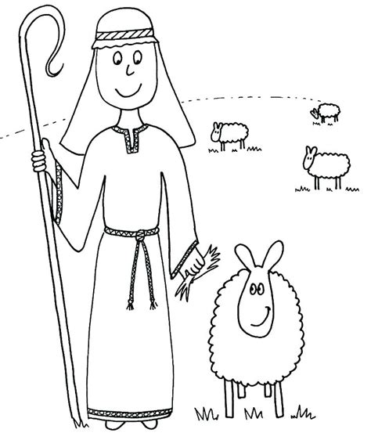

**I am the Good Shepherd**

**Cambridge Causeway**

Autumn 2023

Bible Study notes

**Jesus said ‘I am…’**

**4. I am the Good Shepherd**

By Chrissy Cole